ViBrain User Manual



Software Ver. 0.02  
Manual Ver. 0.02  
(Nov-28th, 2018)

VIDI Labs, UC Davis

Table of Contents

1. Introduction 4

2. Installation 5

2.1 Quick Installation (Mac OS) 5

2.1.1 Install and Verify XCode 5

2.1.2 Run the installer 5

2.2 Quick Installation (Ubuntu) 5

2.2.1 Run the installer 6

2.3 Manual Installation (Mac OS) 6

2.3.1 Install and Verify XCode 6

2.3.2 Install Qt5 6

2.3.3 Install R and R Packages 6

2.3.4 Install Qt Creator 7

2.3.5 Build and Run ViBrain 7

3. Quick Start With Example Data 10

3.1 Load Example Data 10

3.2 Play with Example Data 10

4. Data Format 12

4.1 Directory Structure 12

4.2 Brain Mesh Data 12

4.2.1 brain_mesh.txt 13

4.2.2 spatial_correlation.csv 13

4.3 ROI (Region of Interest) Data 14

4.3.1 roi.csv 14

4.4 Scanned Data 15

4.4.1 File format rule of scanned data 15

4.5 Visualization Style Data 18

4.5.1 point_colors.csv 18

4.5.2 point_shapes.csv 19

4.5.3 group_colors.csv 19

4.5.4 correlation_colormap.csv 19

4.5.5 uncertainty_colormap.csv 20

5. Setting Panel 21

5.1 Matrix Used for MDS 21

5.2 MDS Distance Calculation Method 21

5.3 Filtering 21

5.4 Visual Encoding 21

6. Main Window 22

7. Comparison View 23

7.1 Move, Scale, and Selection 23

7.2 Settings and Functions 23

8. Matrix View 25

8.1 Hovering and Selection 25

8.3 Set a Range of Correlation Values Displayed 25

8.3 Settings and Functions 25

9. Brain Graph View 27

9.1 Rotate, Scale, and Hovering 27

9.2 Settings and Functions 27

10. Information View 28

10.1 Selection of Displayed Information 28

10.2 Selection of Items 28

10.3 Change Matrix Order 28

# 1. Introduction

ViBrain is a visual analytic system, which is developed for brain functional connectivity comparison across individuals, groups, and time points. ViBrain has been extended from our research below.

“Takanori Fujiwara, Jia-Kai Chou, Andrew M. McCullough, Charan Ranganath, and Kwan-Liu Ma. A visual analytics system for brain functional connectivity comparison across individuals, groups and time points. In Proceedings of IEEE Pacific Visualization Symposium (PacificVis), pp. 250-259, 2017.”  
  
The current version supports macOS (tested on macOS Mojave) and Ubuntu (tested on 18.04 LTS).

This manual provides information about installation, quick introduction of the software, and detailed descriptions of usage.

Contact Information:

Takanori Fujiwara [tfujiwara@ucdavis.edu](mailto:tfujiwara@ucdavis.edu)

# 2. Installation

Note: current version supports macOS (tested on Mojave) and Ubuntu (tested on 18.0.4 LTS).

2.1 Quick Installation (Mac OS)

This installation method would influence your “R” and “qmake” environments. If you do not prefer this, try 2.2 Manual Installation. During installation, Internet connection and administration authorization is required.

2.1.1 Install and Verify XCode

* Install latest XCode from Mac App store
* After finishing installation of XCode, launch XCode at once to verify XCode.
* If XCode asks installation of additional required components, select “Install”.

### Run the installer

* Run “install.sh” in “vibrain” directory.  
  cd *path_to_your_vibrain_directory*   
  chmod +x install.sh  
  ./install.sh   
  During the installation, if the password is asked, enter your login password.  
    
  This installer makes “vibrain.app” in “vibrain” directory.   
  The installer launches ViBrain automatically and installs required R packages for the first time (it will spend for a while). You can launch ViBrain by clicking on “vibrain.app” after installation.

2.2 Quick Installation (Ubuntu)

This installation method would influence your “R” environment. During installation, Internet connection and administration authorization is required. If you want to install manually, refer commands in “install.sh”.

### Run the installer

* Run “install.sh” in “vibrain” directory.  
  cd *path_to_your_vibrain_directory*   
  chmod +x install.sh  
  ./install.sh   
  During the installation, if the password is asked, enter your login password.  
    
  This installer makes executable “vibrain” in “vibrain” directory.   
  The installer launches ViBrain automatically and installs required R packages for the first time (it will spend for a while). You can launch ViBrain by clicking on “vibrain” after installation.

## Manual Installation (Mac OS)

Installation method by manual is explained below. If you chose 2.1 Quick installation, skip this section.

### 2.3.1 Install and Verify XCode

* Install latest XCode from Mac App store
* After finishing installation of XCode, launch XCode at once to verify XCode.

### 2.3.2 Install Qt5

* Install Qt. If you use home brew(<http://brew.sh>) use the commands below

brew update

brew install qt5

* Check qmake version.

qmake –v

if the version is lower than qt5, use the command below and restart your terminal.

brew link --force --overwrite qt5

### 2.3.3 Install R and R Packages

* Install the latest R with home brew.   
  brew install R

Check linking for R installed via brew.

brew link R

### 2.3.4 Install Qt Creator

* Download and Install QtCreator from <http://download.qt.io/official_releases/qtcreator/>.

### 2.3.5 Build and Run ViBrain

* Launch "src/qt/vibrain.pro" with QtCreator.
* If QtCreator says no kits, select "options" link and configure kits as follows.

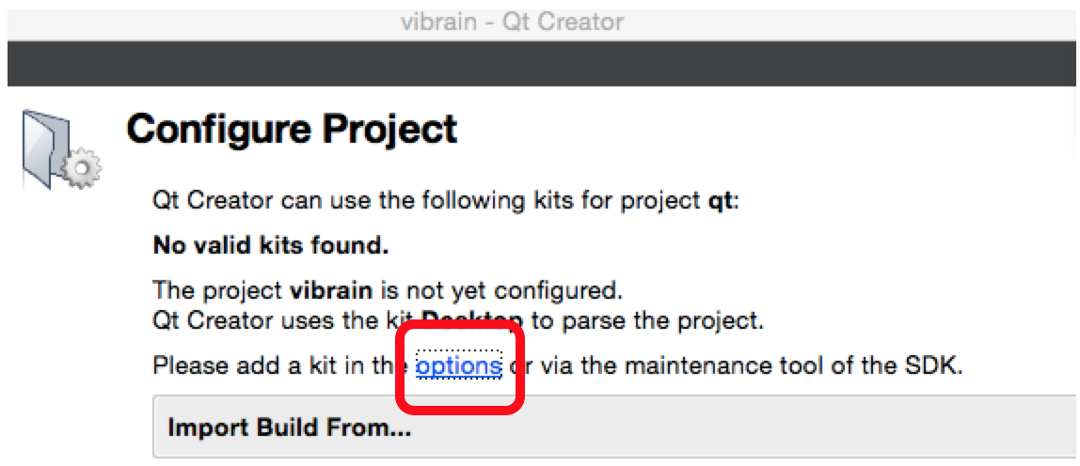

Configure Kits for Build. go to "preference -> Qt Versions".  
Add "/usr/local/bin/qmake" if there is no Qt.   
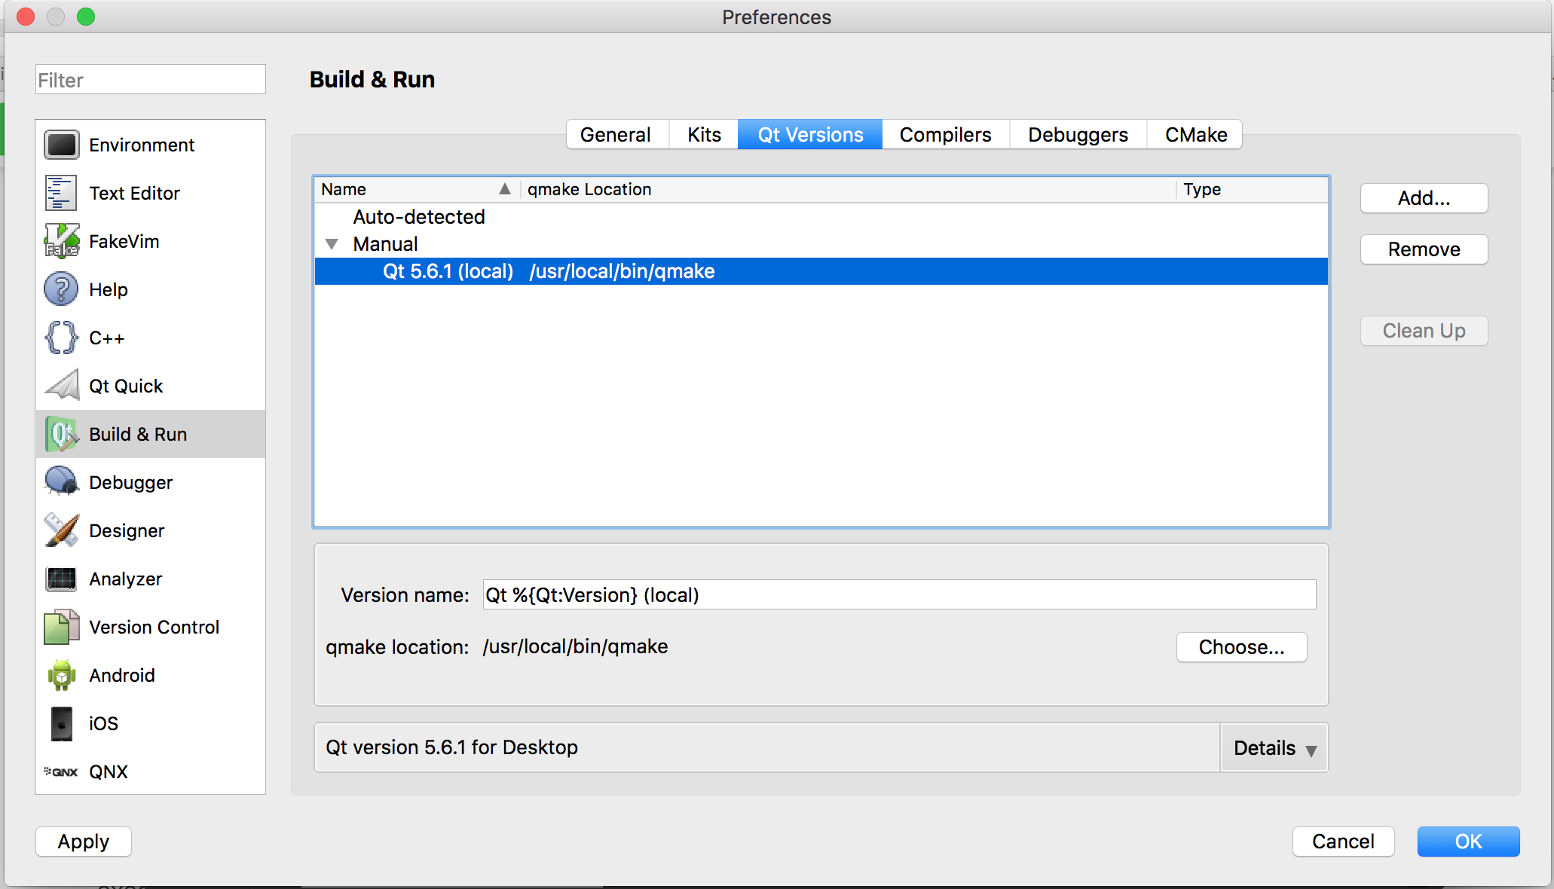  
Then, go to "Kits->Desktop" and select added latest Qt version in "Qt version", select Clang (x86 64bit) in "Compiler".  
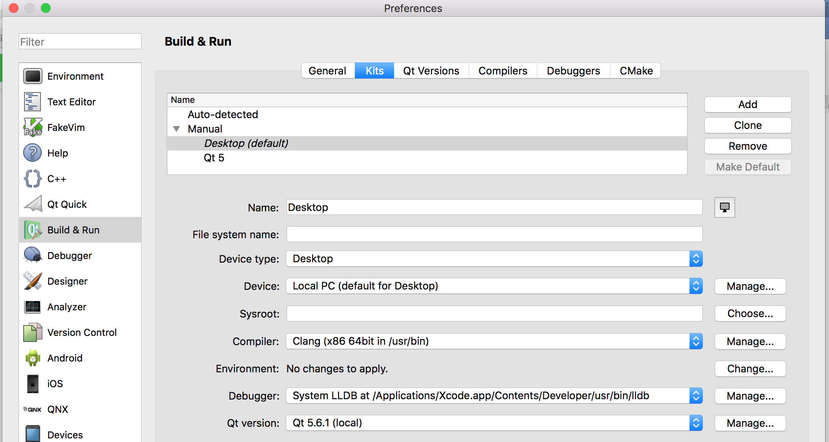

* After finishing above setting, select “Desktop” as a Kit.

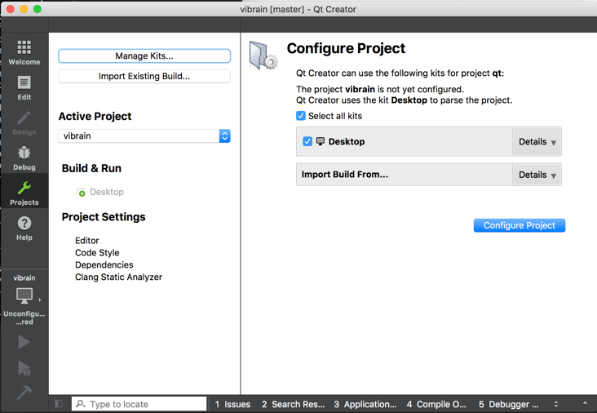

* Select “Release” from a list in the computer icon at the bottom left.

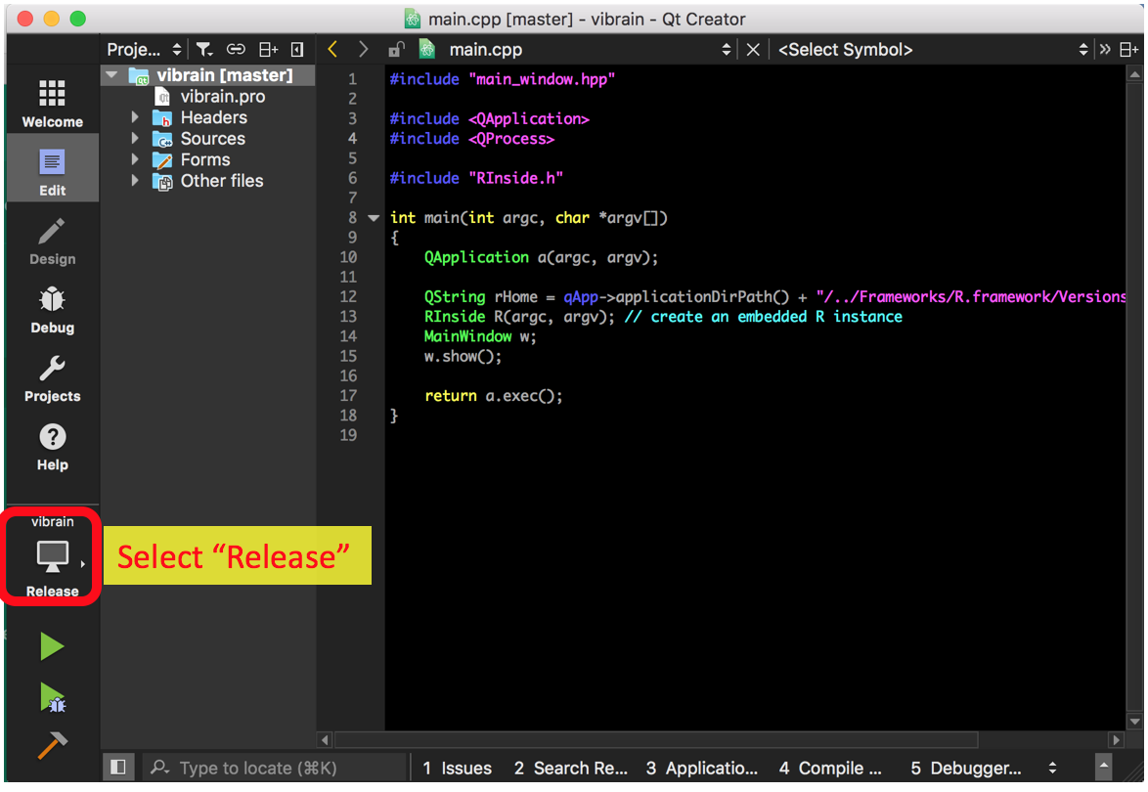

* Build and Run by clicking a green arrow icon at the bottom left in QtCreator.

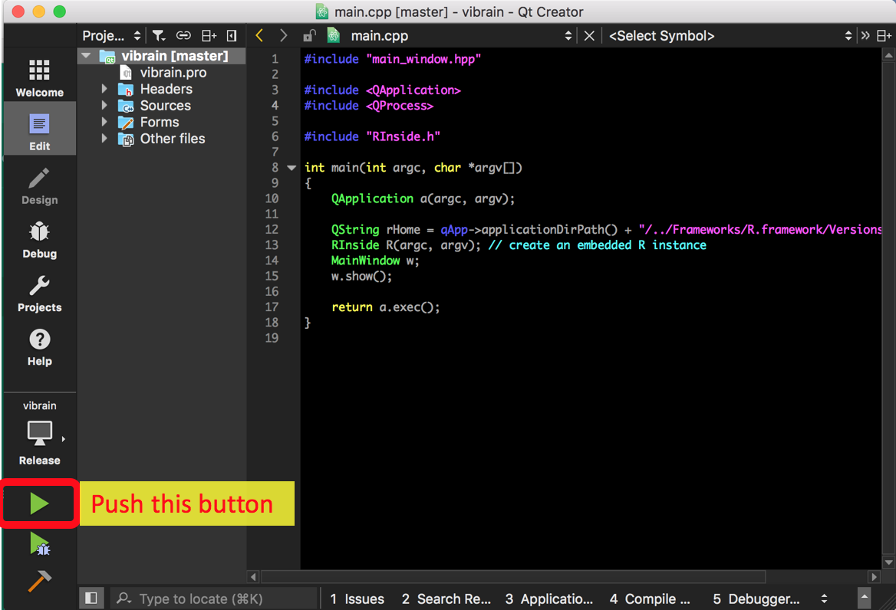

# 3. Quick Start With Example Data

## 3.1 Load Example Data

When you start up the software (by clicking on “vibrain.app” or the green arrow icon in QtCreator mentioned in the previous page), a dialog for selecting data directory will be popped up. Select a directory of example data. You can find the directory (“example_data”) in the software.

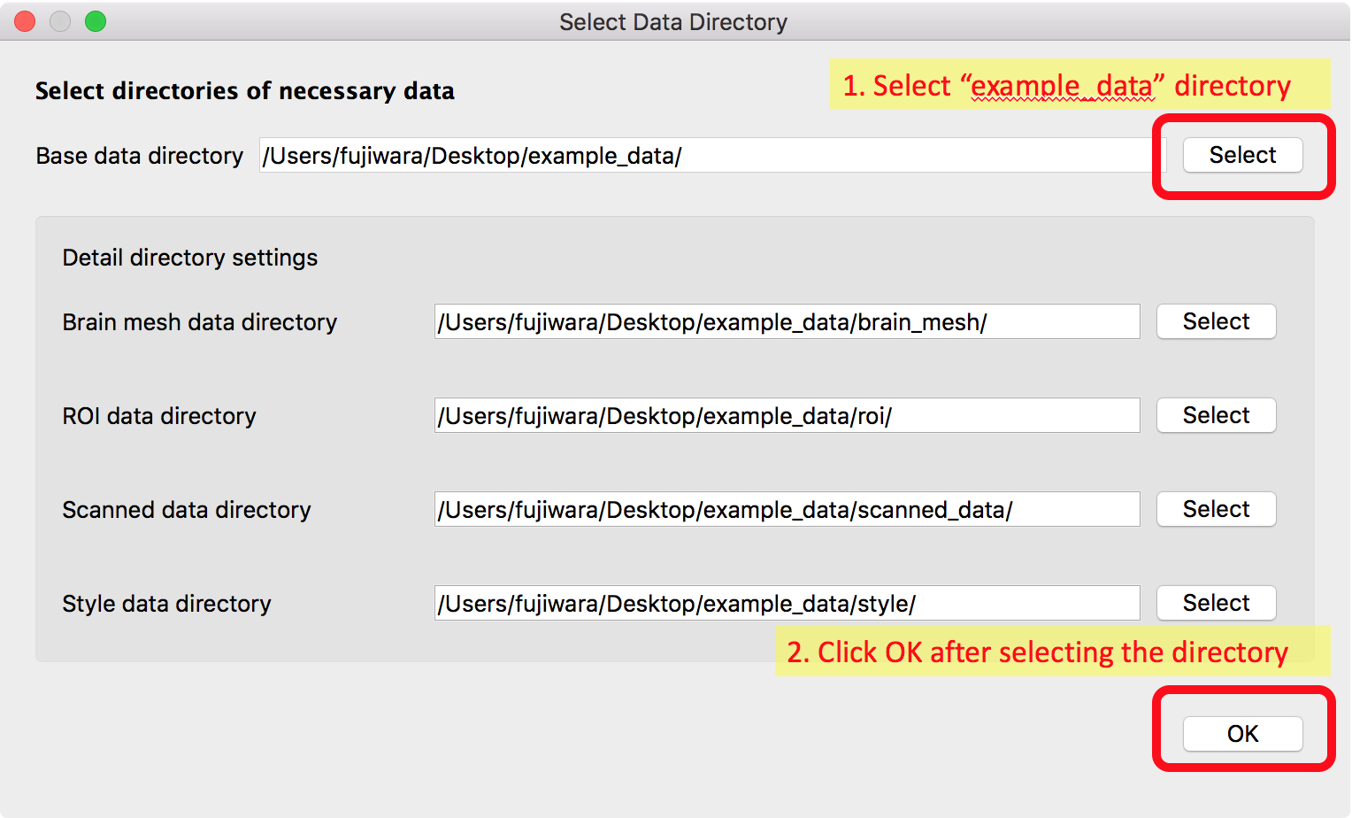

## 3.2 Play with Example Data

After loading the example data, windows below will appear.

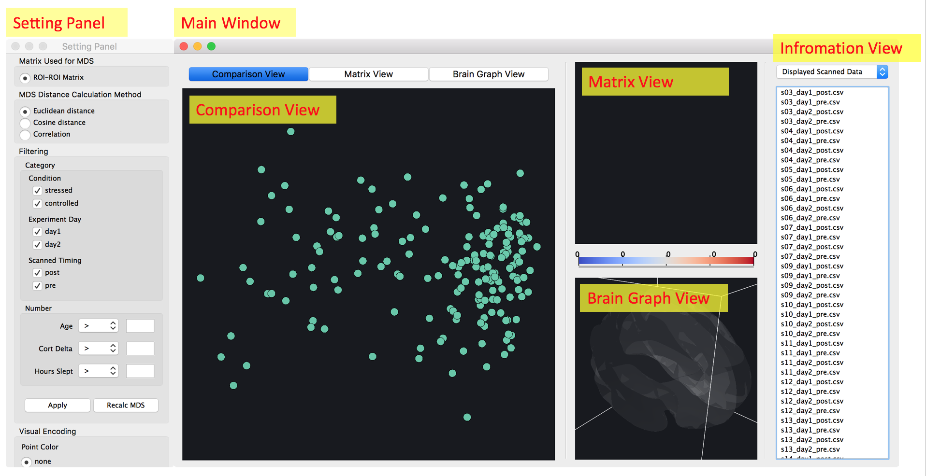

You can try functions listed below in each view/panel. You can find the detailed description in later chapters.

* Setting Panel: you can set several settings and filter the data.
* Main Window
  + Comparison View: scanned dataset of all subjects is placed by using MDS (Multi-dimensional Scaling), which is a dimensionality reduction method to show the data similarity. More similar data are placed more close. You can select a subset of them and apply several functions. Try to select some of them and right-click. You can find options you can apply, including showing a matrix in other views.
  + Matrix View: this view displays a matrix generated from selected matrix (matrices) in the comparison view. You can reorder the matrix with clustering algorithms, select cells and show them in the brain graph, etc. Try to select cells with dragging and/or right-click to show options. Also, you can use sliders placed under the matrix view and change thresholds to select displayed cells.
  + Brain Graph View: this view shows 3D brain network with a brain image. You can rotate and zoom the graph and right-click to show options.
  + Information View: You can select listing information from a drop down list. If you select “order of matrix”, you can change matrix order by dragging and dropping the listed names of ROIs. Additionally, with “Setting subset of ROIs” which is appeared by right-clicking, you can set subset of ROIs to be shown in the other views.

# 4. Data Format

## 4.1 Directory Structure

Our default directory structure to contain all necessary data is as follows.

* “a directory contains all data”
* **brain_mesh**: contains 3D brain mesh used in the brain graph view
* **roi**: contains ROI information
* **scanned_data**: contains each scanned data including a ROI-ROI matrix, demographics, etc.
* **style**: contains color style, etc. for visualization

This structure corresponds with a dialog for selecting data directory. When you set a base data directory, child-directories are automatically set as a default. If you want to use other directories, you can select each of them in the dialog.

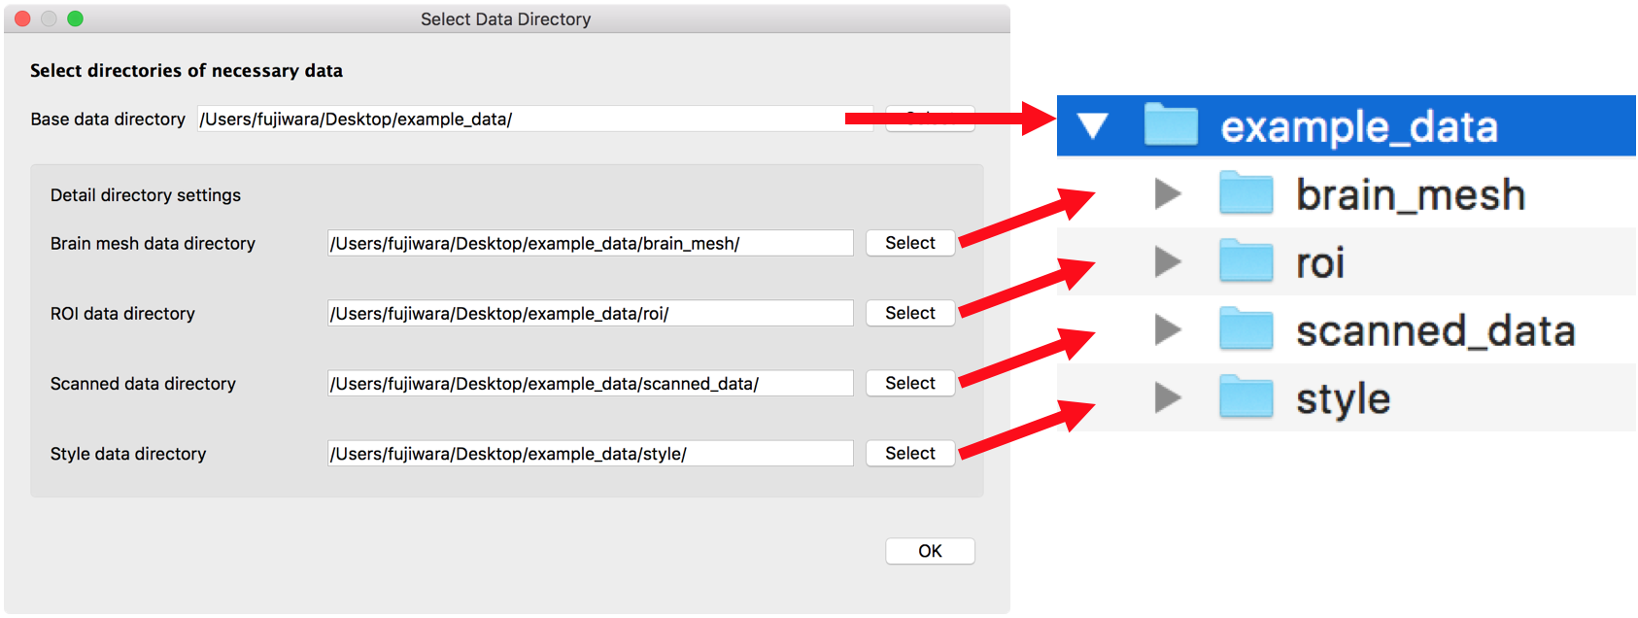

In a description in the following sections, we use these default names for the directories.

## 4.2 Brain Mesh Data

“brain_mesh” directory must include files listed below. Copying these files from the example data is the simplest way for preparing these. If you want to use your own data, you need to prepare these based on file rules we explain below.

1. brain_mesh.txt
2. spatial_correction.csv

### brain_mesh.txt

This file contains mesh information for drawing a brain image in the brain graph view. You need to prepare information below.

1)  Number of Vertices (must be an integer value, *e.g., 81924*)

2)  Vertex coordinates   
 (must be three values for each line, *e.g., -2.886495 24.886947 15.909558*)

3)  Number of Triangle faces (must be an integer value, *e.g., 163840*)

4)  Indices of vertex making up the triangles  
 (must be three integer values for each line, *e.g., 3 10243 10245*)

The file format is described below. We will use *m* as the number of vertices, *n* as the number of triangle faces.

*brain_mesh.txt*

*format*

|  |  |
| --- | --- |
| Line no | Text in the file |
| 1  2  3  …  m+1  m+2  m+3  m+4  …  m+n+2 | *m*  *vertex coordinate 1*  *vertex coordinate 2*  *…*  *vertex coordinate m*  *n*  *vertex indices for triangle 1*  *vertex indices for triangle 2*  *…*  *vertex indices for triangle n* |

*example*

|  |  |
| --- | --- |
| Line no | Text in the file |
| 1  2  3  …  81925  81926  81927  81928  …  245766 | 81924  -2.886495 24.886947 15.909558  -13.916695 -58.985245 19.655311  …  13.322185 -58.528173 19.165734  163840  3 10243 10245  10243 2563 10244  …  40964 71284 79459 |

### spatial_correlation.csv

This file is for adjusting the brain mesh size and positions to fit the brain image to measured ROI positions. For example, this is for the case that you might obtain the brain mesh data from open source data, but your measured data uses different scale from that brain mesh data. You need to prepare information below.

1)  Translation to x, y, z-directions (must be values, *e.g., 0.0,0.07,0.0*)

2)  Scale of x, y, z-directions (must be values, *e.g., 0.0047,0.0047,0.0047*)

The file format is described below. The easy way to make this file is copying and editing the example file.

*spatial_correlation.csv*

*format*

|  |  |
| --- | --- |
| Line no | Text in the file |
| 1  2 | translate x,translate y,translate z,scale x,scale y,scale z  *value for translate x*,*y*,*z*,*value for scale x,y*,*z* |

*example*

|  |  |
| --- | --- |
| Line no | Text in the file |
| 1  2 | translate x,translate y,translate z,scale x,scale y,scale z  0.0,0.07,0.0,0.0047,0.0047,0.0047 |

## 4.3 ROI (Region of Interest) Data

“roi” directory must include a file below.

1. roi.csv

### roi.csv

This file contains information about ROIs. This information is used for deciding names, positions in the brain graph view, groups belongs to, ranks in the matrix of ROIs. You need to prepare information below.

1)  names of ROIs (cannot include comma, *e.g., atlas.FP r*)

2)  positions of ROIs (must be values, *e.g., 26.15585218,52.14318378,8.25781733*)

3)  groups of ROIs (must be non-negative integer values, *e.g.,* *0*)

4)  ranks in a matrix order (must be integer values, *e.g.,0*)

If you use a negative number for ranks, the corresponding ROI then will not be displayed in the matrix.   
The file format is described below. The easy way to make this file is copying and editing the example file.

*rois.csv*

*format*

|  |  |
| --- | --- |
| Line no | Text in the file |
| 1 | name,x,y,z,group,rank |
| 2  3  … | *name of ROI 1, x,y,z position of ROI 1,group of ROI 1, rank of ROI1*  *name of ROI 2, x,y,z position of ROI 2,group of ROI 2, rank of ROI2*  … |

*example*

|  |  |
| --- | --- |
| Line no | Text in the file |
| 1 | name,x,y,z,group,rank |
| 2  3  … | atlas.FP r,26.15585218,52.14318378,8.25781733,0,0  atlas.FP l,-24.72350164,52.95596920,7.50812227,0,1  … |

## 4.4 Scanned Data

“scanned_data” directory contains information about all scanned data, including attributes, ROI-ROI Matrix, etc. You can add any CSV files (file name does not matter) that satisfies the file format rule explained below in “scanned_data” directory.

### File format rule of scanned data

The file format is described below. The easy way to make this file is copying and editing the example file. You must include at least ROI-ROI matrix information.

*example_scanned_data.csv*

*format*

|  |  |
| --- | --- |
| Line no | *Text in the file* |
| 1 | attribute name,data type,value |
| 2  3  … | *name of attribute 1,data type of attribute 1 value of attribute 1*  *name of attribute 2,data type of attribute 2,value of attribute 2*  …  ROI-ROI Matrix,matrix,  *matrix value, matrix value,…,matrix value*  *…*  *matrix value, matrix value,…,matrix value*  … |

*example*

|  |  |
| --- | --- |
| Line no | *Text in the file* |
| 1 | attribute name,data type,value |
| 2  3  4  5  6  … | Subject ID,id,3  Condition,category,stressed  Age,number,23  Hours Slept,number,7.0  Experiment Day,category,day1  …  ROI-ROI Matrix,matrix,  0,0.606663,0.402629,0.270574,…  …  0,0.606663,0.402629,0.270574,…  … |

The detailed rule for each column is as follows. Only “matrix” data type differs from other types, thus we explain in a different section in detail.

#### **Attribute name**

Attribute name is used for distinguishing each attribute. You can use any name. One exception is “ROI-ROI Matrix”. “ROI-ROI Matrix” is pre-defined name in the system. This name can be only used for the ROI-ROI matrix.

#### **Data Type**

You can use one of system defined type listed below

1. id
2. category
3. number
4. matrix
5. id

“id” would be used for distinguish each subject. However, current system does not use this value (coming soon with new functions).

1. category

With “category”, an attribute is handled in categories in the setting panel.

1. number

With “number”, an attribute is handled in numbers in the setting panel.

1. matrix

With “matrix”, an attribute is handled as an matrix. The matrix will be used for a setting for calculating MDS/displayed matrix in the matrix view.

#### **Value**

Available value differs based on the data type. Available values are as follows.

|  |  |
| --- | --- |
| Data Type | Value |
| id | any characters (e.g., Subject ID) |
| category | any characters (e.g., day1) |
| number | numbers (e.g., -3.245) |
| matrix | (special format explained later) |

#### **Format for matrix**

The format for matrix is a bit different from other data types which is described as follows (a value in row *i* and column *j* is represented as *vij*)

|  |
| --- |
| “Matrix Name”, matrix,  *v11, v12, …, v1n*  *v21, v22, …, v2n*  *…*  *vm1, vm2, …, vmn*  [a newline] |

“ROI-ROI Matrix” is a pre-defined name for representing the ROI matrix. You must include “ROI-ROI Matrix” in the file. You can also add other matrices in the file. For these matrices, you can use any name except for “ROI-ROI Matrix”.

Here is an example of the description.

|  |
| --- |
| ROI-ROI Matrix,matrix,  0.0,0.1,0.2,0.3  0.1,0.0,0.4,0.5  0.2,0.4,0.0,0.7  0.3,0.5,0.7,0.0  Task-Task Matrix,matrix,  0,1,2  1,0,3  2,3,0 |

## 4.5 Visualization Style Data

“style” directory includes styles for visualization. “style” directory must include files below.

1. point_colors.csv
2. point_shapes.csv
3. group_colors.csv
4. correlation_colormap.csv
5. uncertainty_colormap.csv

Our recommending parameters are in the example data. Therefore, you can simply use the files in the example data. Or, you can set your styles as desired.

### point_colors.csv

This file contains colors of points visualized in the comparison view. These colors are used for visual encoding for the category data. The file format is described below. The easy way to use this file is by copying and editing the example file.

*point_colors.csv*

*format*

|  |  |
| --- | --- |
| Line no | *Text in the file* |
| 1  2  3  … | R,G,B,A  *Red,green,blue,alpha value for color label 1*  *Red,green,blue,alpha value for color label 2*  *…* |

*example*

|  |  |
| --- | --- |
| Line no | *Text in the file* |
| 1  2  3  … | R,G,B,A  102,194,165,255  252,141,98,255  *…* |

### point_shapes.csv

This file contains shapes of points visualized in the comparison view. These shapes are used for visual encoding for the category data. The shape is defined by the number of sides i.e. 3 for a triangle, 4 for a square, etc. 0 is used for a circle. The file format is described below.

*point_shapes.csv*

*format*

|  |  |
| --- | --- |
| Line no | *Text in the file* |
| 1  2  3  … | sides(0:circle 3:triangle 4:rectangle...)  *sides of a shape for label1*  *sides of a shape for label2*  *…* |

*example*

|  |  |
| --- | --- |
| Line no | *Text in the file* |
| 1  2  3  … | sides(0:circle 3:triangle 4:rectangle...)  0  3  *…* |

### group_colors.csv

This file contains colors of groups visualized in the matrix and brain graph views. These colors are used for coloring groups defined in the rois.csv or the clustered results with the clustering algorithms. The file format is described below.

*group_colors.csv*

*format*

|  |  |
| --- | --- |
| Line no | *Text in the file* |
| 1  2  3  … | R,G,B,A  *Red,green,blue,alpha value of a color for group 1*  *Red,green,blue,alpha value of a color for group 2*  *…* |

*example*

|  |  |
| --- | --- |
| Line no | *Text in the file* |
| 1  2  3  … | R,G,B,A  231,138,195,255  166,216,84,255  *…* |

### correlation_colormap.csv

This file contains the colors of the color map used for visualizing the correlation value in a matrix cell. By default, we use 256 resolution color map in the example data, you can increase/decrease the line numbers to create a color map with higher/lower resolution.

*correlation_colormap.csv*

*format*

|  |  |
| --- | --- |
| Line no | *Text in the file* |
| 1  2  3  … | R,G,B,A  *Red,green,blue,alpha value 1*  *Red,green,blue,alpha value 2*  *…* |

*example*

|  |  |
| --- | --- |
| Line no | *Text in the file* |
| 1  2  3  … | R,G,B,A  59,76,192,255  60,78,194,255  … |

### uncertainty_colormap.csv

This file contains colors of a color map for visualizing uncertain values in the comparison view. By default, we use 256 resolution color map in the example data, you can increase/decrease the line numbers to create a color map with higher/lower resolution.

*uncertainty_colormap.csv*

*format*

|  |  |
| --- | --- |
| Line no | *Text in the file* |
| 1  2  3  … | R,G,B,A  *Red,green,blue,alpha value 1*  *Red,green,blue,alpha value 2*  *…* |

*example*

|  |  |
| --- | --- |
| Line no | *Text in the file* |
| 1  2  3  … | R,G,B,A  1,1,1,255  2,2,2,255  *…* |

# 5. Setting Panel

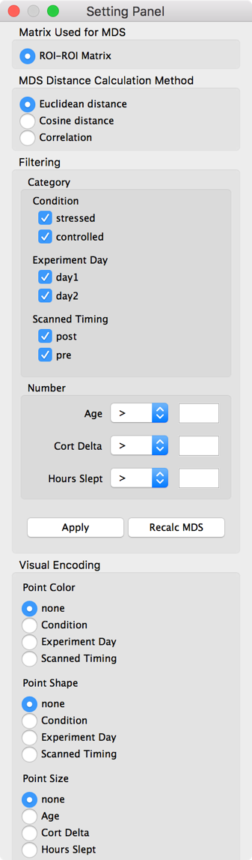The setting panel is used for change the settings of the visualizations in other views (mainly, the comparison view).

## 5.1 Matrix Used for MDS

In the comparison view, scanned data are placed by calculating distance (dissimilarity) between each matrix. By default, it uses the ROI-ROI matrices to do the distance calculation. You can also use another type of matrices if you have defined in the scanned data files.

## 5.2 MDS Distance Calculation Method

Several measures are possible to consider as the distance metric. The current system supports three measures: 1) Euclidean distance, 2) cosine distance and 3) correlation.

## 5.3 Filtering

You can filter points displayed in the comparison view. After setting conditions, if you push “Apply”, the points that are not in selected conditions are filtered out. If you push “Recalc MDS”, positions of points in the comparison view are recalculated for the points in selected conditions with MDS.

## 5.4 Visual Encoding

You can change the visual encodings for resenting the points in the comparison view. In the current system, color and shape of a point can be applied for the category type data to map to the categorical attribute that a subject obtains, while the size of a point can be used to represent a numerical attribute.

# 6. Main Window

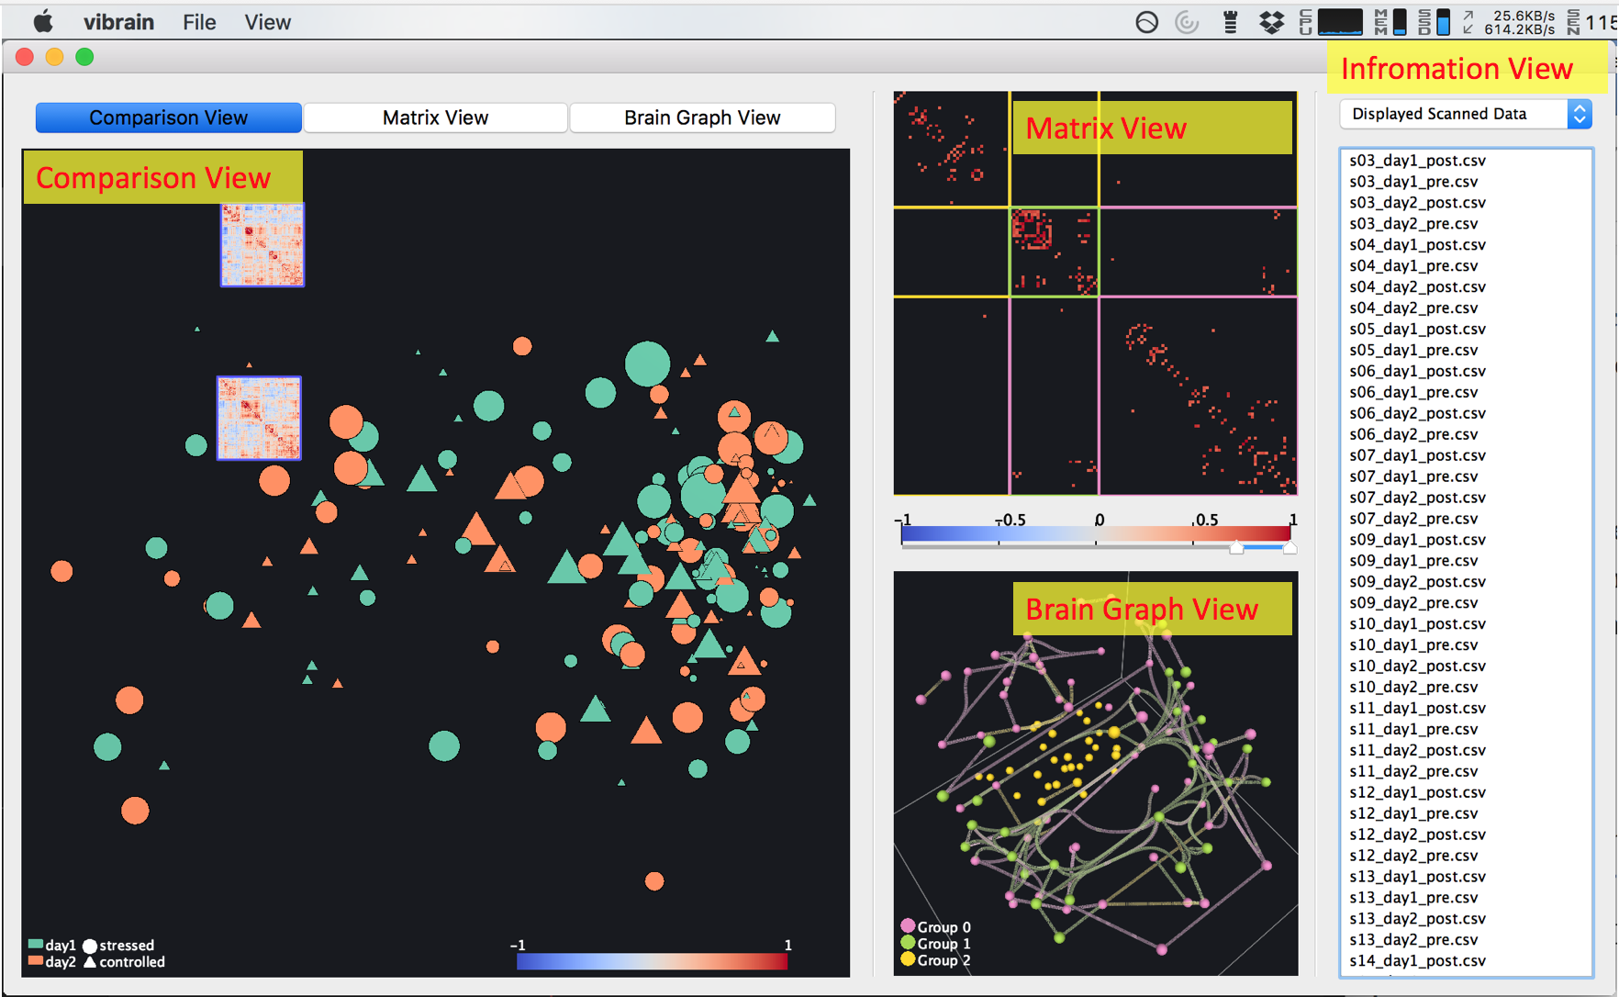

The main window consists of four views: the 1) comparison, 2) matrix, 3) brain graph, 4) information views. Each view is explained in the following sections. On the top of the main window, you can select which view you want to display in the largest window.

# 7. Comparison View

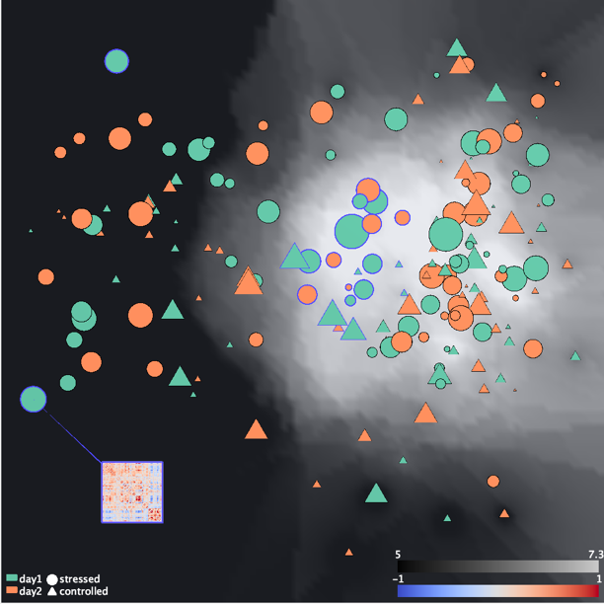The comparison view is designed for comparing multiple fMRI scan data. Each scan is placed according to the similarity between each other by applying MDS (multi-dimensional scaling). In theory, similar subjects are placed more closely to each other. You can see the difference/similarity between the data quickly. Additionally, you can show more detailed information in other views by applying functions as desired.

## 7.1 Move, Scale, and Selection

You can move an entire image by dragging with right mouse button. Mouse scrolling changes the scale of the image. By left-clicking a point, you can select a point one-by-one. You can use lasso for selection by dragging with left mouse button. Selected points are marked with blue colors.

## 7.2 Settings and Functions

You can see applicable settings and functions by right-clicking. All options are listed below.

* Clear selection
* Show matrices on selected points (available when at least one point is selected)
* Hide all matrices (available when at least one matrix is displayed)
* Hide selected matrices (available when at least one point is selected)
* Show matrix in other views (available when only one point is selected)
* Show averaged matrix in other views (available when multiple points are selected)
  + This function generates an averaged matrix with the average value for each cell in the matrix between selected points. Then, the averaged matrix is displayed in other views.
* Show diff matrix in other views (available when exactly two points are selected)
  + This function generates a subtracted matrix by subtracting a value of each cell in a matrix of first selected point from the other selected point. Then, the matrix is displayed in other views.
* Show standard deviation matrix in other views (available when multiple points are selected)
  + This function generates a standard deviation (SD) matrix by calculating SD for each cell between selected points. Then, the matrix is displayed in other views.
* Show max - min matrix in other views (available when multiple points are selected)
  + This function generates a max - min matrix by subtracting the minimum value for each cell from the maximum value for the corresponding cell between selected points. Then, the matrix is displayed in other views.
* Recalculate MDS with selected points (available when more than three points are selected)
  + This function recalculates positions of selected points with MDS.
* Show/Hide MDS uncertainty
  + This functions switches show/hide MDS uncertainty. High values of MDS uncertainty mean areas where the distances in the original dimension are not well preserved. Please, refer the paper as you want to know this measure in detail.
* Change MDS uncertainty settings
  + You can change the color scale and the number of neighbors considered when the system calculates MDS uncertainty. Smaller number of neighbors reflects more local values of MDS uncertainty.
* Change Correlation color map min and max

# 8. Matrix View

The matrix view shows a selected/generated matrix from the comparison view. You can apply clustering algorithms, select cells for displaying them in the brain graph view, etc.

## 8.1 Hovering and Selection

When you hover a mouse on a cell in the matrix, the system pops up information about what correlation value it represents and indicate its corresponding row and column.

By left-clicking, you can select a cell one-by-one. When you drag with left mouse button, you can select multiple cells with rectangle selection.

## 8.3 Set a Range of Correlation Values Displayed

You can use sliders placed under the matrix to change a range of correlation values displayed. The cells that have a value between the two sliders will be displayed. You can use a dialog by right-clicking and change the setting of the sliders. With the dialog, you can set the minimum and maximum values of a color map, the slider positions, and a type of range (“within the sliders” or “outside the sliders”).

## 8.3 Settings and Functions

You can see applicable settings and functions by right-clicking. All options are listed below.

* Clear selection
* Recalculate MDS with selected elements (available when at least one cell is selected)
  + By using this function, positions of points in the comparison view are recalculated by considering only selected cells for calculating distances in the MDS calculation.
* Reset elements used in MDS
* Arrange with Hierarchical Clustering (available when an ROI-ROI matrix is displayed)
  + This function runs complete-linkage algorithm for clustering. You can also set the number of clusters generated as desired. The generated clusters are represented by colored rectangle lines.
* Arrange with Modularity (available when an ROI-ROI matrix is displayed)
  + This function runs the Louvain method for detecting community with modularity optimization. This function could produce better clustering result than the hierarchical clustering. However, calculation cost is high and it would spend a long time. This algorithm select the number of clusters automatically to optimize the modularity. The generated clusters are represented by colored rectangle lines.
* Use selected ROIs in analysis (available when an ROI-ROI matrix is displayed)
  + This function updates all the visualizations based on the selected ROIs. This includes 1) updating displayed ROIs in the matrix view, brain graph view, and comparison view, 2) updating clustered results in the matrix view and brain graph view based on the current setting, 3) recalculating MDS by only using the selected ROIs for all the points in the comparison view.
* Reset arrange (available when an ROI-ROI matrix is displayed)
* Show selected elements in the brain graph view (available when an ROI-ROI matrix is displayed and at least one cell is selected)
* Reset elements shown in the brain graph view (available when an ROI-ROI matrix is displayed)
* Save matrix files
  + This function outputs matrix values as a CSV file.

# 9. Brain Graph View

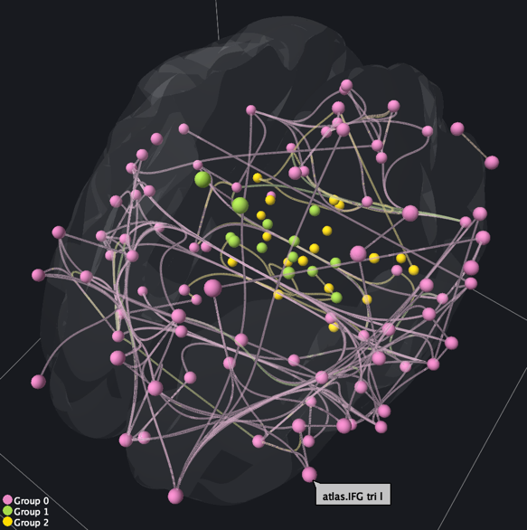 The matrix view shows a 3D graph corresponding to the matrix displayed in the matrix view.

## 9.1 Rotate, Scale, and Hovering

You can rotate the graph around y and z-axes (x and z-axes) by dragging with left (right) mouse button. You can scale the graph by scrolling a mouse. When you hover a mouse on a node, the name of the node will be popped up.

## 9.2 Settings and Functions

You can see applicable settings and functions by right-clicking. All options are listed below.

* Clear selection
* Bundle/Unbundle edges
  + You can select bundling or unbundling edges. The system uses the 3D mean shift edge bundling. Edge bundling requires a long calculation time if you show many edges. Try to apply the edge bundling after reducing the number of displayed edges by using the sliders or other functions described in the previous section.
* Color edges based on the value/group
  + By default, an edge color corresponds to the color of the correlation value of a cell in the matrix view. You can change the setting to make the color map to the group information as derived by the clustering algorithms.
* Show/Hide a brain image
* Show/Hide a cube wire frame

# 10. Information View

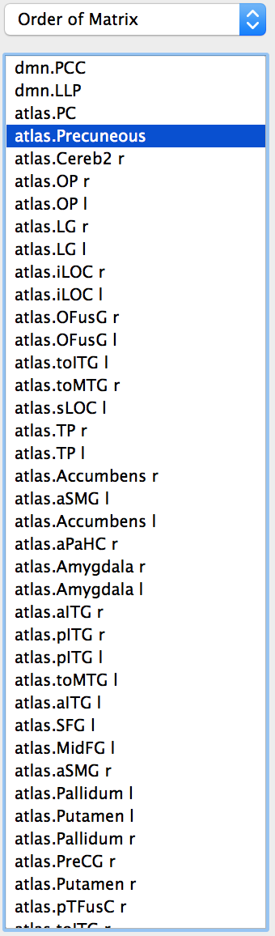The information view shows a listed information about the data, matrix, graph, etc.

## 10.1 Selection of Displayed Information

You can select the displayed information from a drop-down list on the top of the information view. You can select one from options listed below.

* Displayed Scanned Data
* Order of Matrix
* Displayed ROIs in Brain Graph View
* Displayed Edges in Brain Graph View

## 10.2 Selection of Items

You can select one item by clicking. Also, you can select with Ctrl and Shift button like you do the selection with a file system. When you select “Displayed Scanned Data”, “Displayed ROIs in Brain Graph View”, or “Displayed Edges in Brain Graph View”, multiple items can be selected with dragging.

## 10.3 Change Matrix Order

When you select “Order of Matrix”, you can change the matrix order from the information view. Select items and then drag them to the preferred location in the list. The matrix order in the comparison and matrix views will then be changed simultaneously.   
Additionally, with “Setting a subset of ROIs” which appeared with right click, you can set ROIs used in an analysis.